Artificial Intelligence

Name : J .Anisha Jenifer
Reg no: 192511004

Experiment 5: Vacuum Cleaner Problem

Aim: Simulate a simple vacuum cleaner agent.

Algorithm
1. Read room states.
2. Clean dirty room.
3. Move to next room.
4. Stop when clean.

Pseudo Code
Start
If dirty clean
Move
Repeat
Stop

Python Program
# Vacuum Cleaner Problem
rooms = {"A": "Dirty", "B": "Dirty"}
for r in rooms:
if rooms[r] == "Dirty":
print("Cleaning", r)
rooms[r] = "Clean"
print(rooms)

Input
{'A':'Dirty','B':'Dirty'}

Output
Cleaning A
Cleaning B
{'A': 'Clean', 'B': 'Clean'}

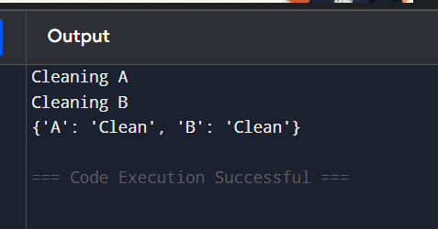

Experiment 6: Missionaries and Cannibals Problem

Aim
To solve the Missionaries and Cannibals problem using Python.

Algorithm
1. Represent the initial and goal states.
2. Generate valid boat moves.
3. Check safety constraints.
4. Repeat until the goal state is reached.
5. Display the solution path.

Pseudo Code
Start
Initialize initial and goal states
Generate valid moves
Check constraints
Repeat until goal
Display solution
Stop

Python Program

from collections import deque
def solve():
start = (3, 3, 1)
goal = (0, 0, 0)
queue = deque([(start, [start])])
visited = {start}
moves = [(1, 0), (2, 0), (0, 1), (0, 2), (1, 1)]
while queue:
(m, c, b), path = queue.popleft()
if (m, c, b) == goal:
return pat
for dm, dc in moves:
if b == 1:
nm = m - dm
nc = c - dc
nb = 0
else:
nm = m + dm
nc = c + dc
nb = 1
if 0 <= nm <= 3 and 0 <= nc <= 3:
if (nm == 0 or nm >= nc) and ((3 - nm) == 0 or (3 - nm) >= (3 - nc)):
state = (nm, nc, nb)
if state not in visited:
visited.add(state)
queue.append((state, path + [state]))
return None
result = solve()
print("Solution Path:")
if result:
for state in result:
print(state)
else:
print("No solution found"
)

Output
(3, 3, 1)
...
(0, 0, 0)

